

INDIVIDUAL ASSIGNMENT

LANKA

COMP40004

**WEB DEVELOPMENT AND OPERATING SYSTEMS-1**

**CF22A1COM,CF22A1SE, CF22A1CS**

ASSIGNMENT 2 AND 3 HAND IN – 15TH NOV 2022

ASSIGNMENT 2 HAND OUT – 20TH JAN 2023

ASSIGNMENT 3 HAND OUT – WEEK 18

WEIGHTAGE: ASSIGNMENT 2: 30% ASSIGNMENT 3: 30%

**INSTRUCTION TO CANDIDATES:**

1. **Students are advised to underpin their answers with the use of references (cited using the Harvard Name System of Referencing).**
2. **Late submission will be awarded zero (0) unless Extenuating Circumstances (EC) are upheld.**
3. **Cases of plagiarism will be penalized.**
4. **Assignment presentation should be submitted in the form of softcopy and hardcopy both; modeling work should be submitted in softcopy form.**

WDOS Assignment Report

(Sheedh Mashood - CB009892)

Table of Contents

Introduction 2

Link to the Website 2

Wireframes 2

Homepage Page 3

Turtle Categories Page 4

Hikkaduwa Hatchery Page 5

Threats to Turtles Page 6

Solution Page 7

Other Hatcheries Page 8

Kosgoda Page 9

Bentota Page 10

Purchase and Donate Page 11

Website 12

Homepage 12

Categories Page 13

Hikkaduwa Hatchery Page 13

Threats to Turtles Page 14

Solution Page 16

Other Hatcheries Page 16

Kosgoda Page 18

Bentota Page 19

Purchase and Donate Page 20

Conclusion 20

# Introduction

Sea Turtles Sri Lanka, an online website which showcases the turtle population in Sri Lanka. Educating the locals as well as the outsiders the importance of sea turtles, the threats towards sea turtles and the environment in Sri Lanka. Moreover, this page supports the turtle conservations located in Sri Lanka by showcasing their turtle hatcheries and by allowing users to purchase their merch as well as donate.

# Link to the Website

(<https://sheedhmashood.github.io/SeaTurtleSriLanka/Home.html>)

# Wireframes

(Upcoming Pages)

## A picture containing text, screenshot, diagram, parallel Description automatically generatedHomepage Page

## Turtle Categories Page

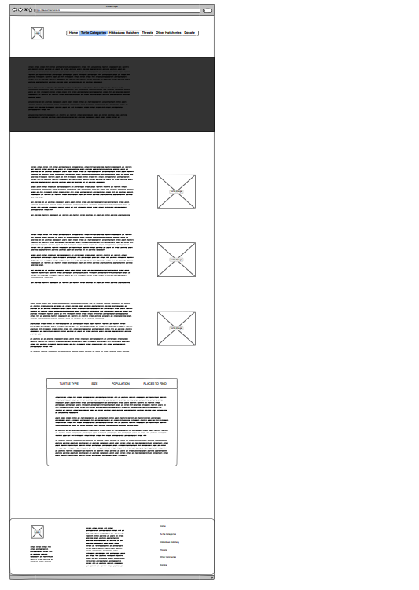

## Hikkaduwa Hatchery Page

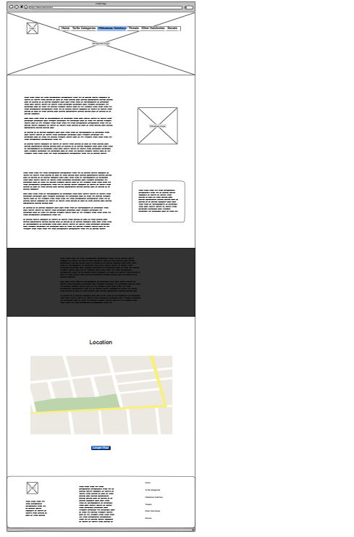

## Threats to Turtles Page

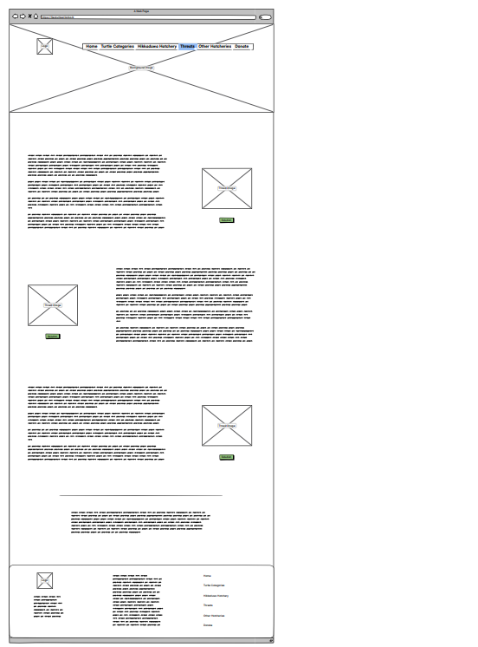

## Solution Page

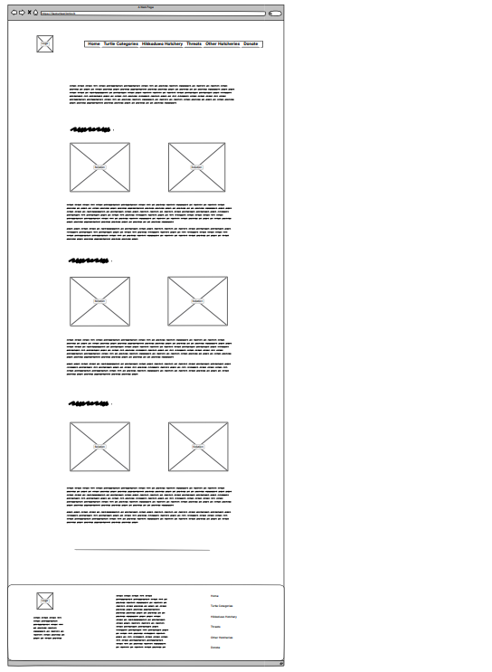

## Other Hatcheries Page

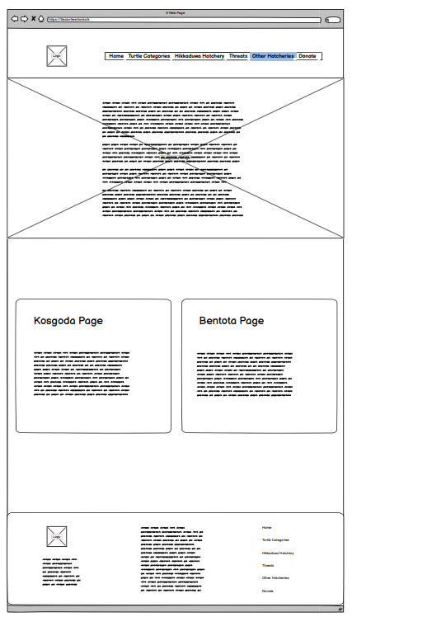

## Kosgoda Page

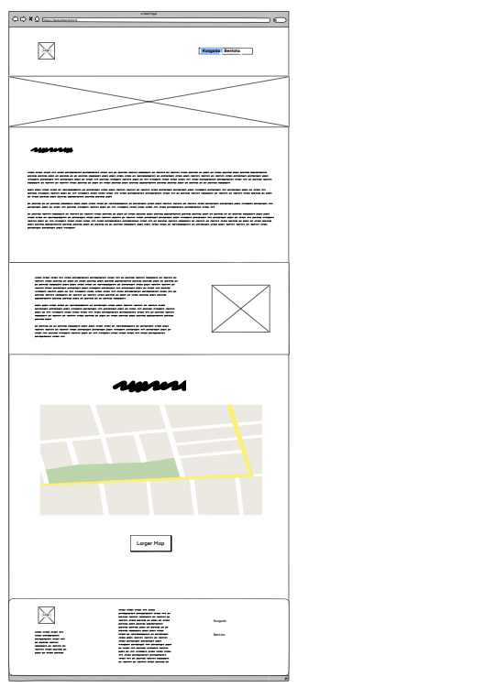

## Bentota Page

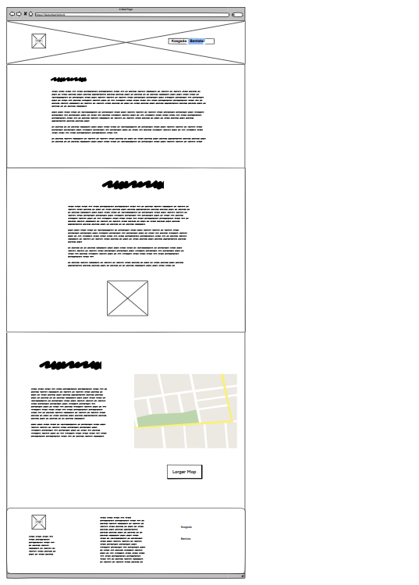

## Purchase and Donate Page

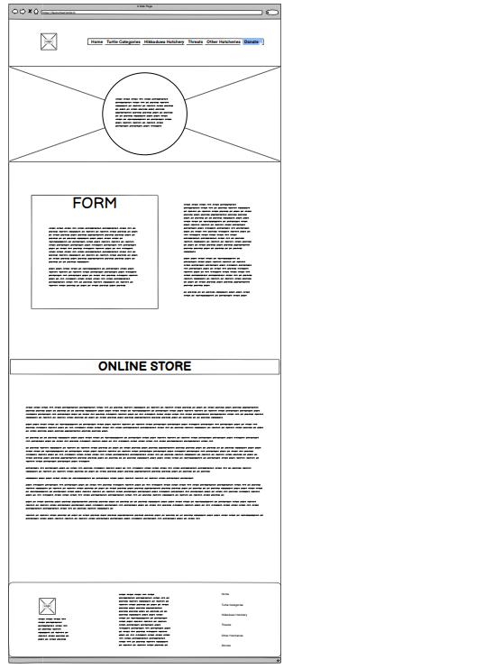

# Website

## Homepage

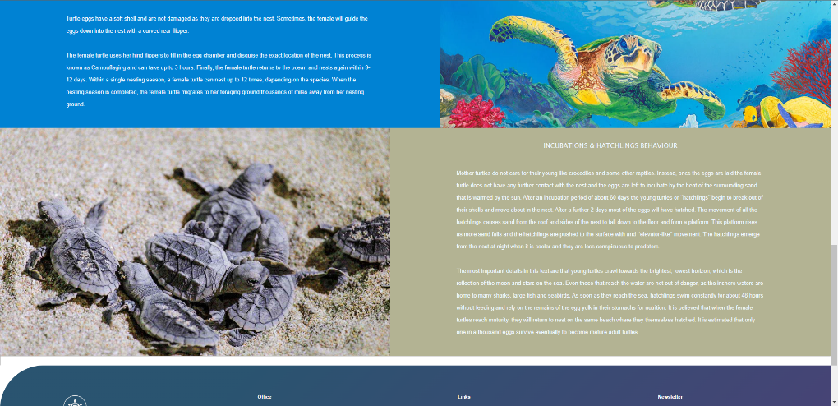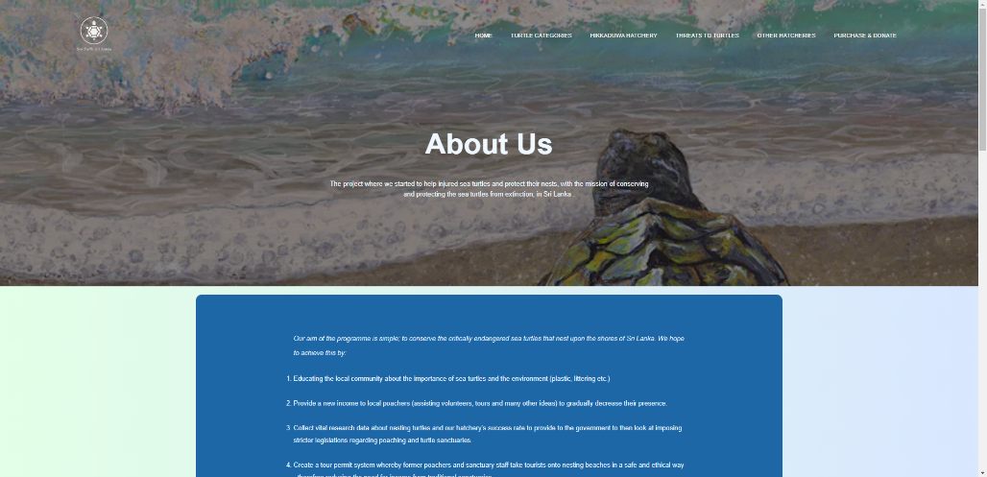

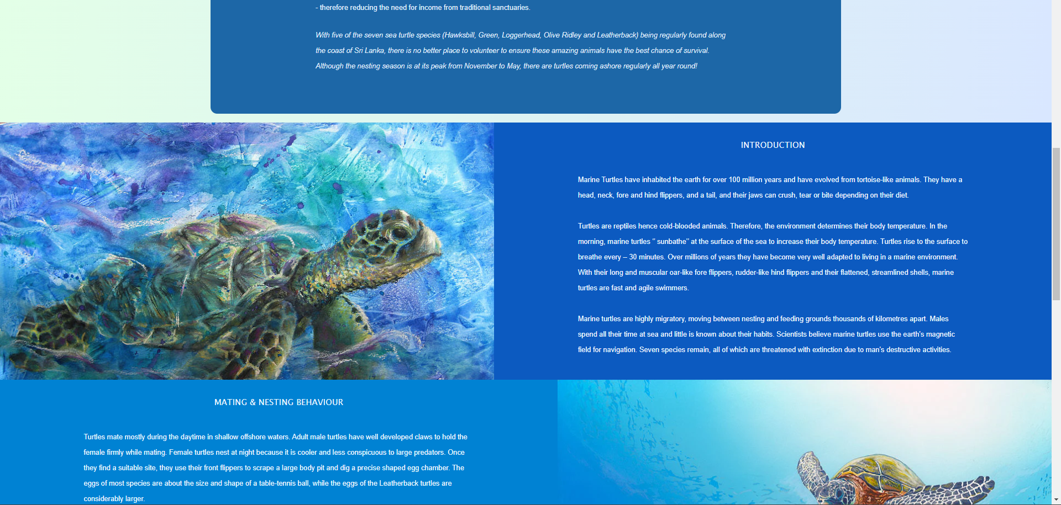

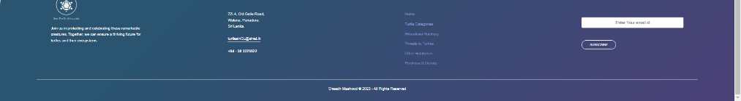

## Categories Page

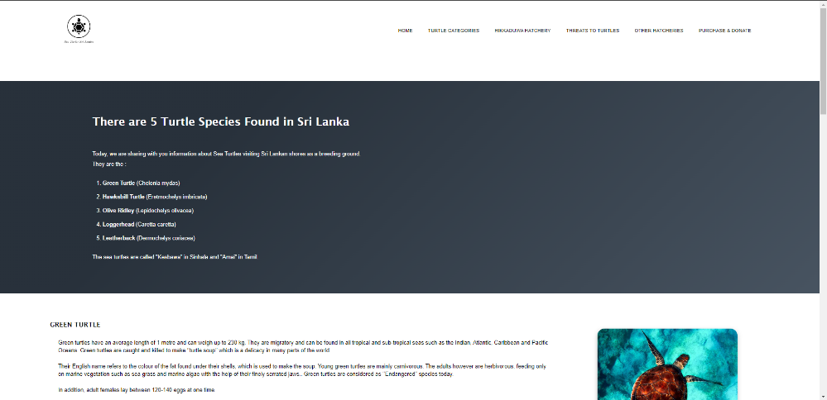

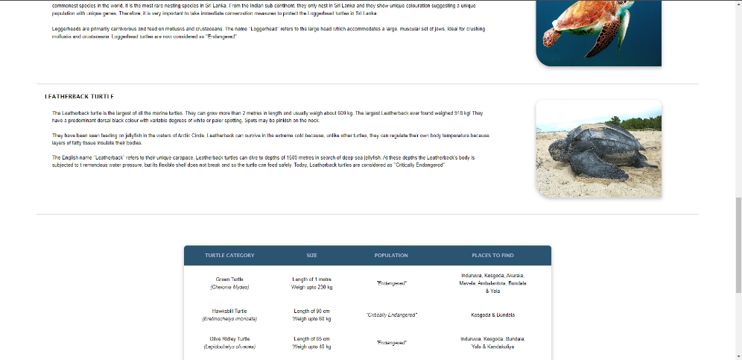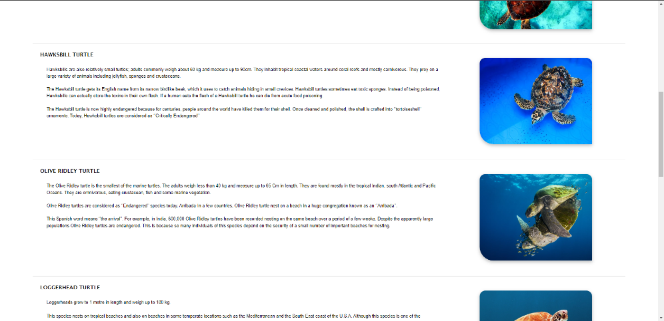

## A screenshot of a computer Description automatically generated with medium confidenceHikkaduwa Hatchery Page

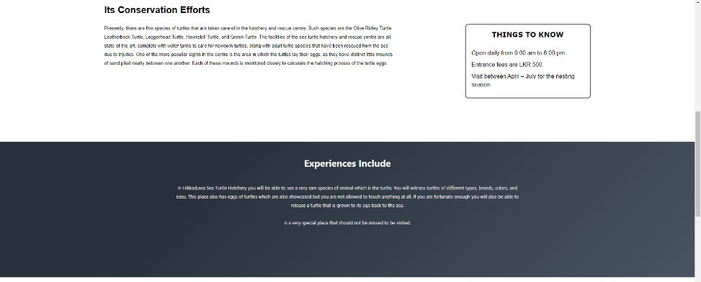

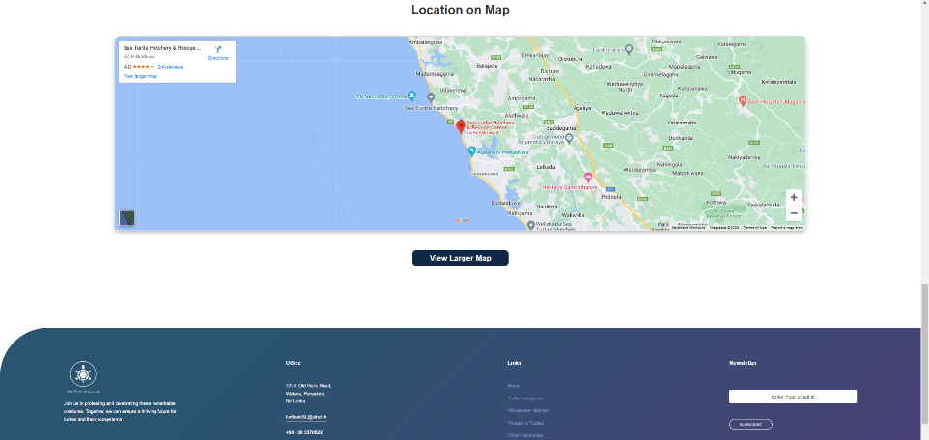

## Threats to Turtles Page

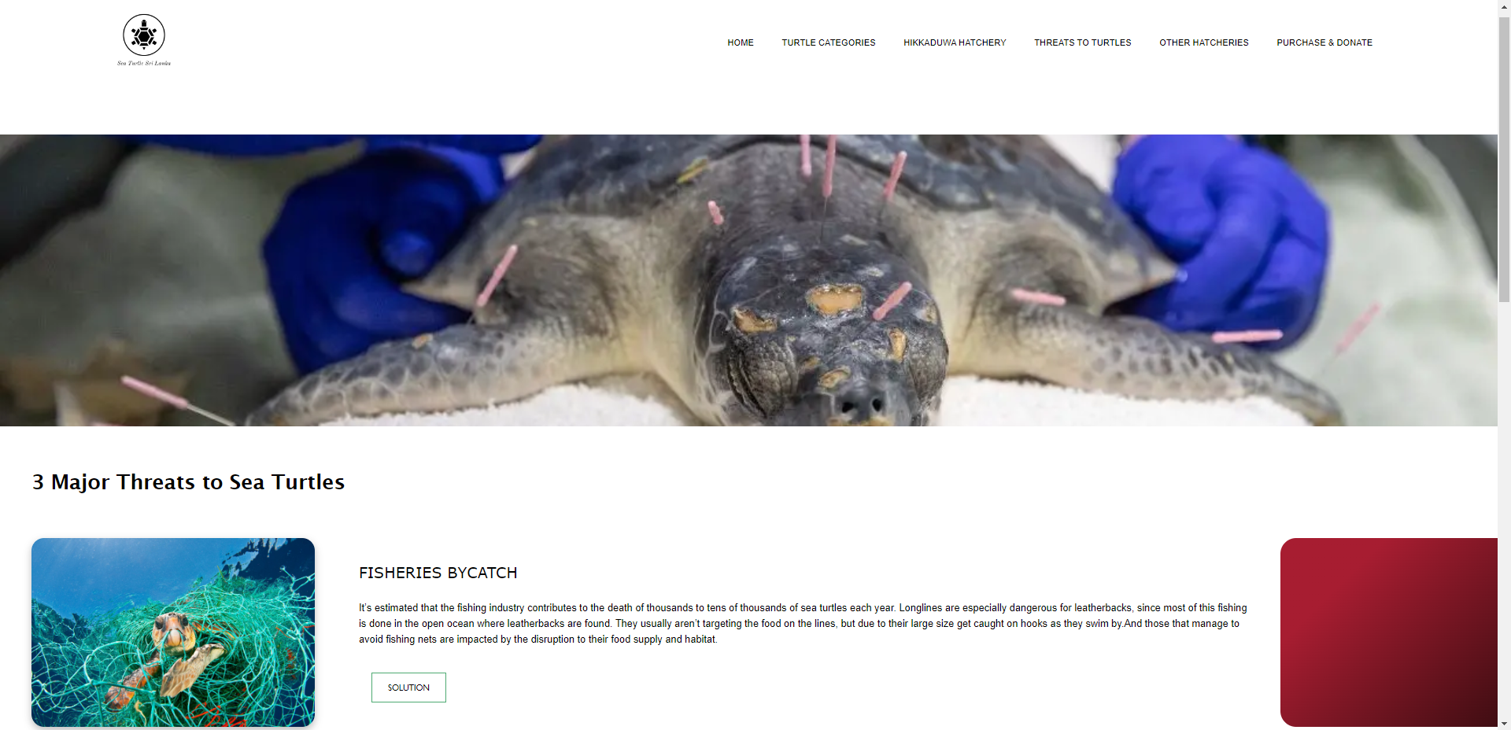

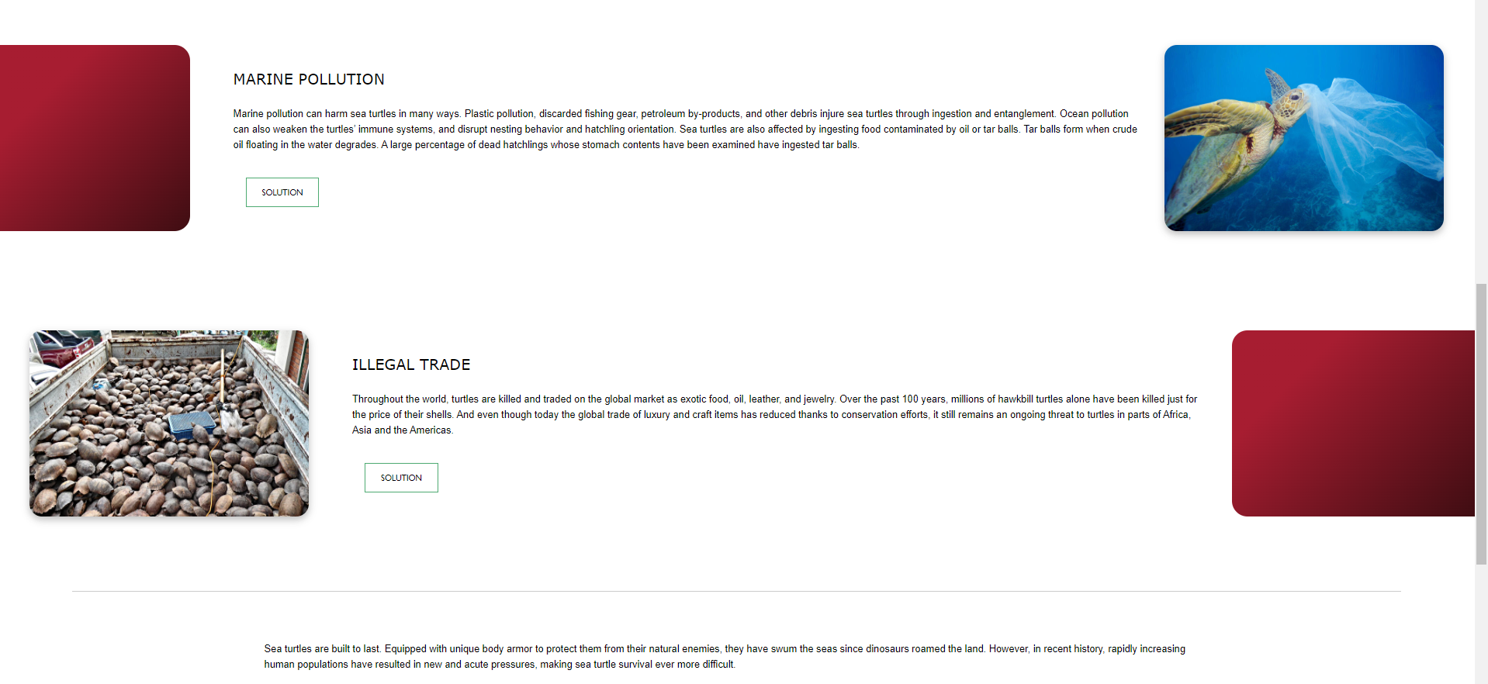

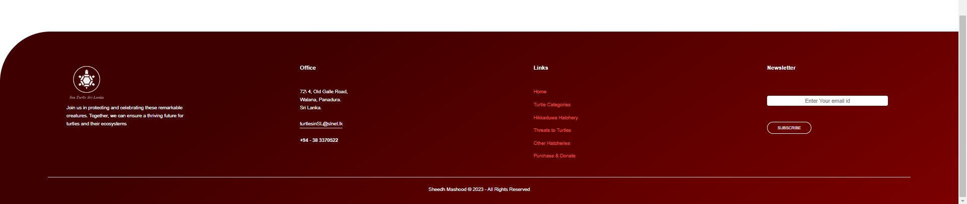

## A screenshot of a website Description automatically generated with low confidenceSolution Page

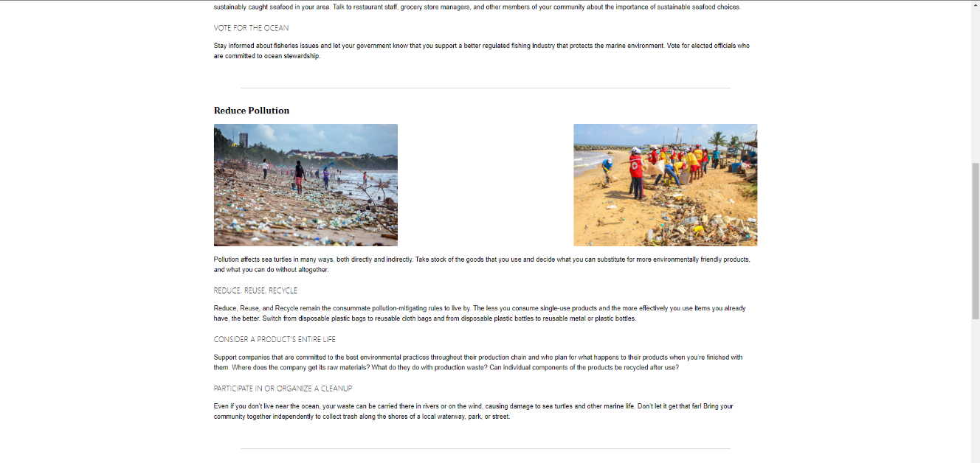

## A screenshot of a website Description automatically generated with low confidenceOther Hatcheries Page

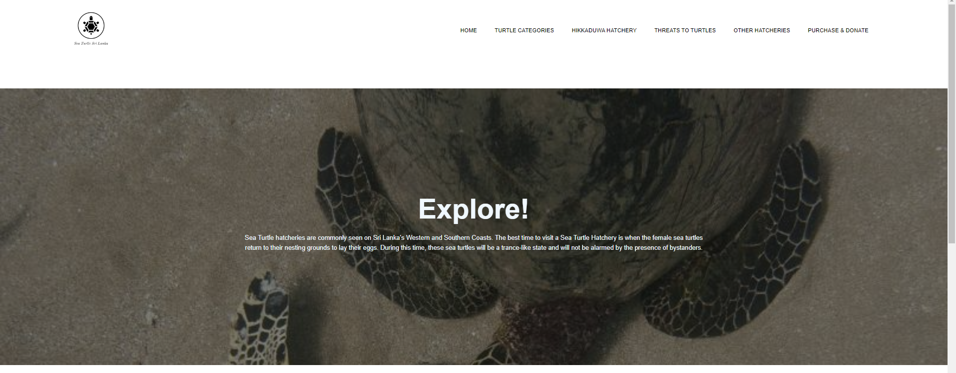

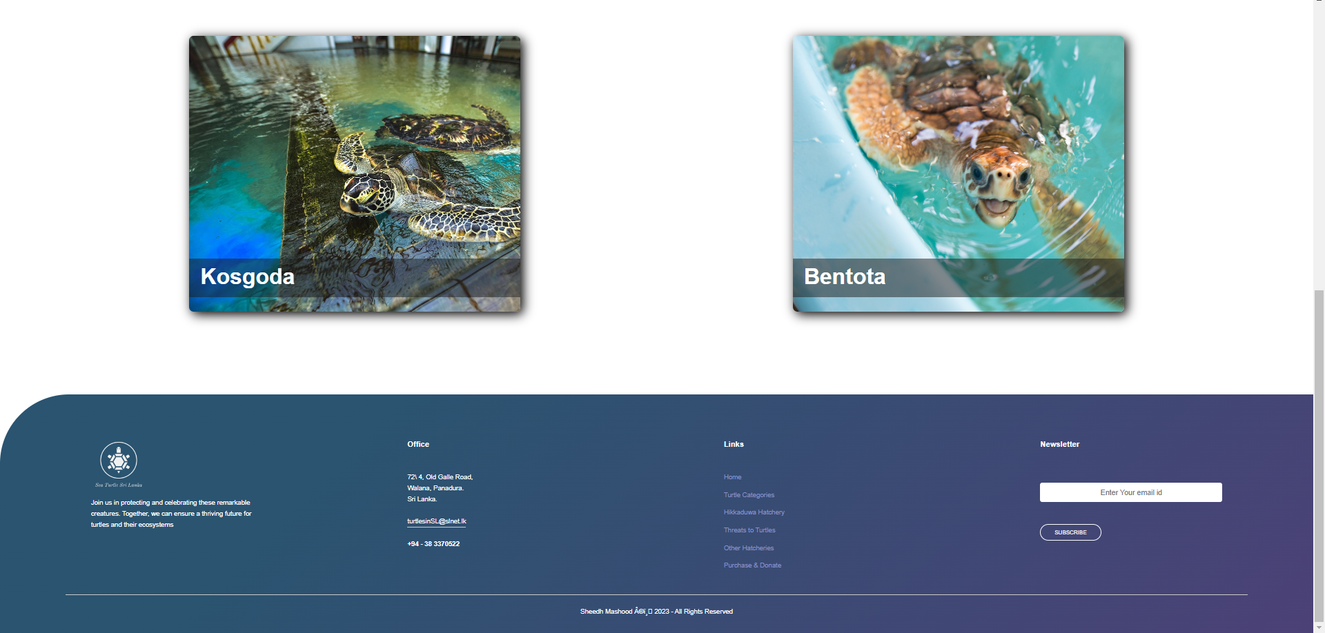

## Kosgoda Page

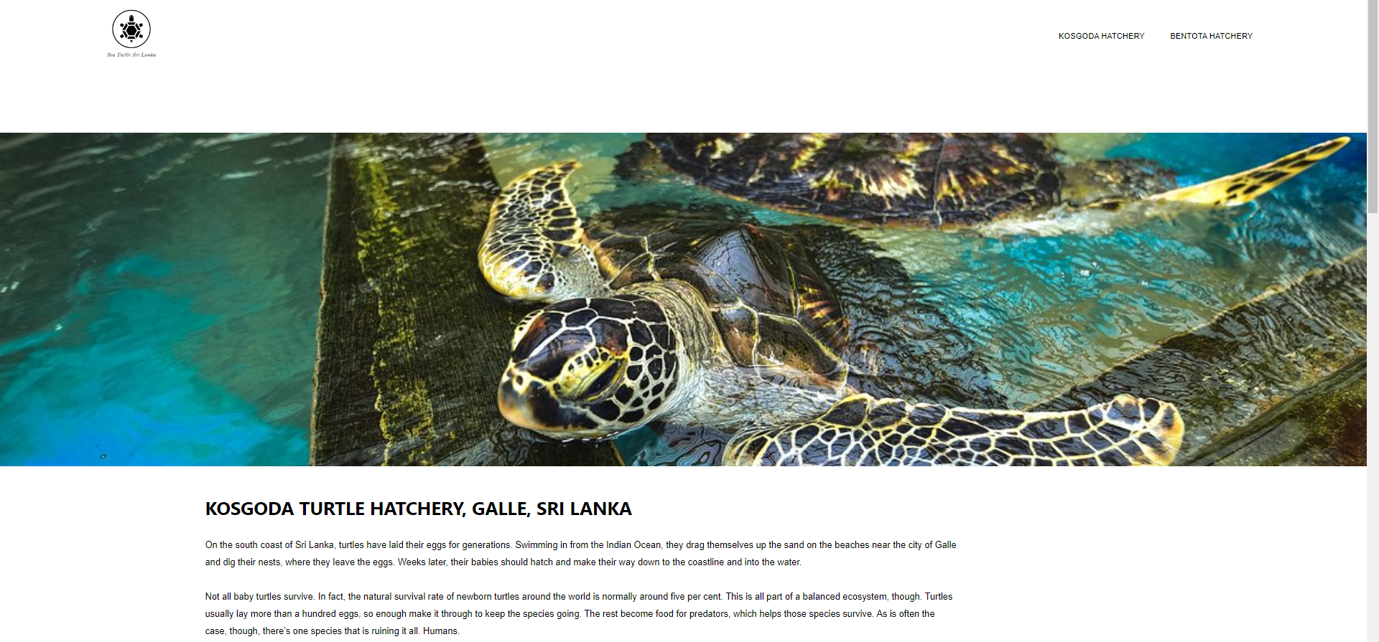

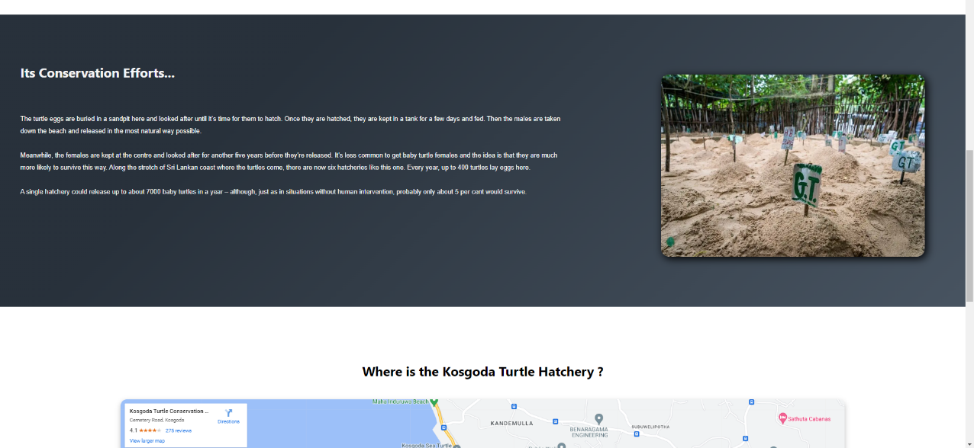

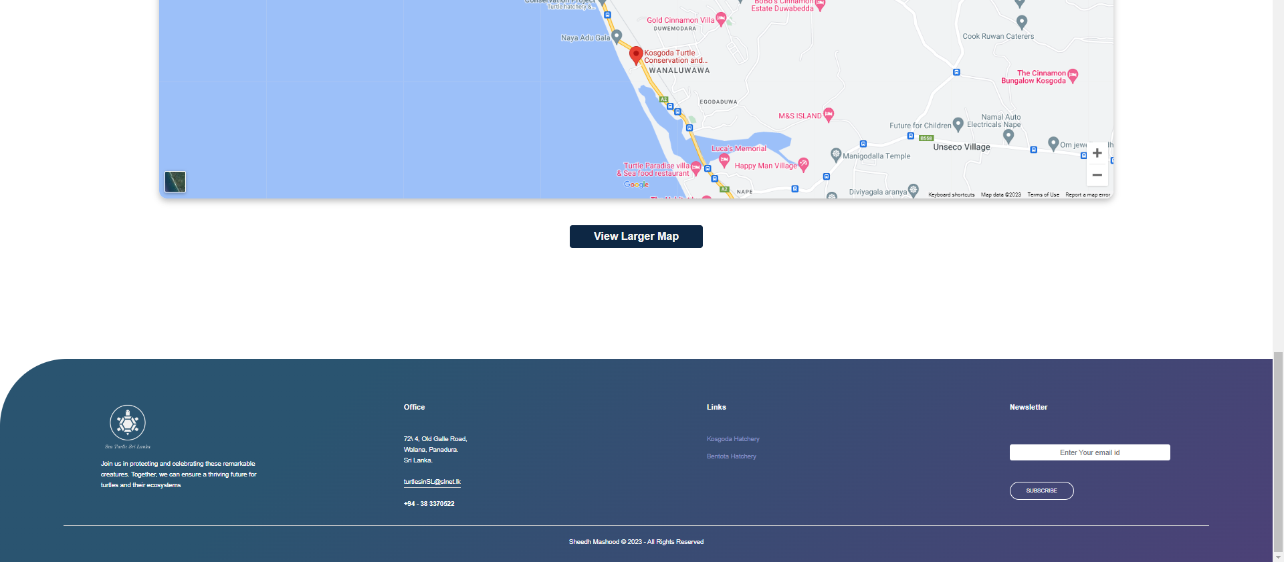

## A screenshot of a computer Description automatically generated with medium confidenceA screenshot of a computer Description automatically generated with low confidenceBentota Page

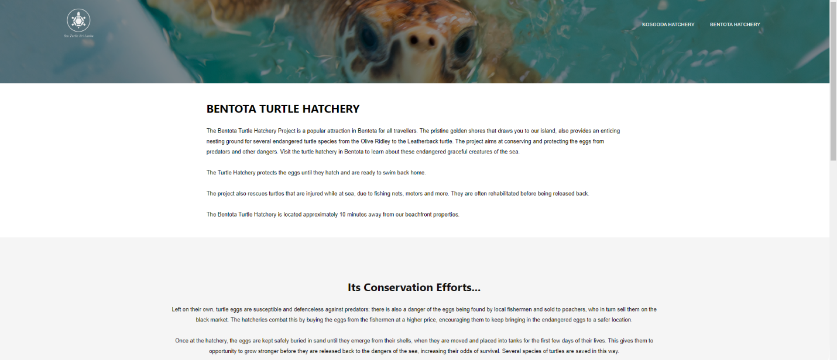

## Purchase and Donate Page

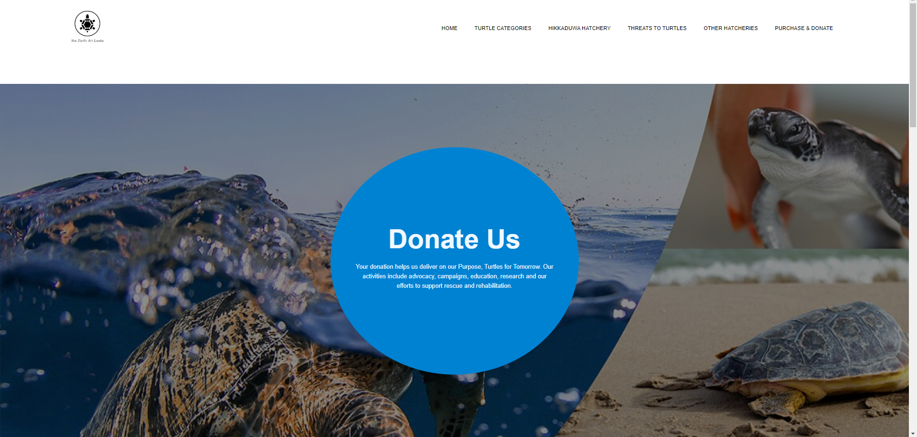

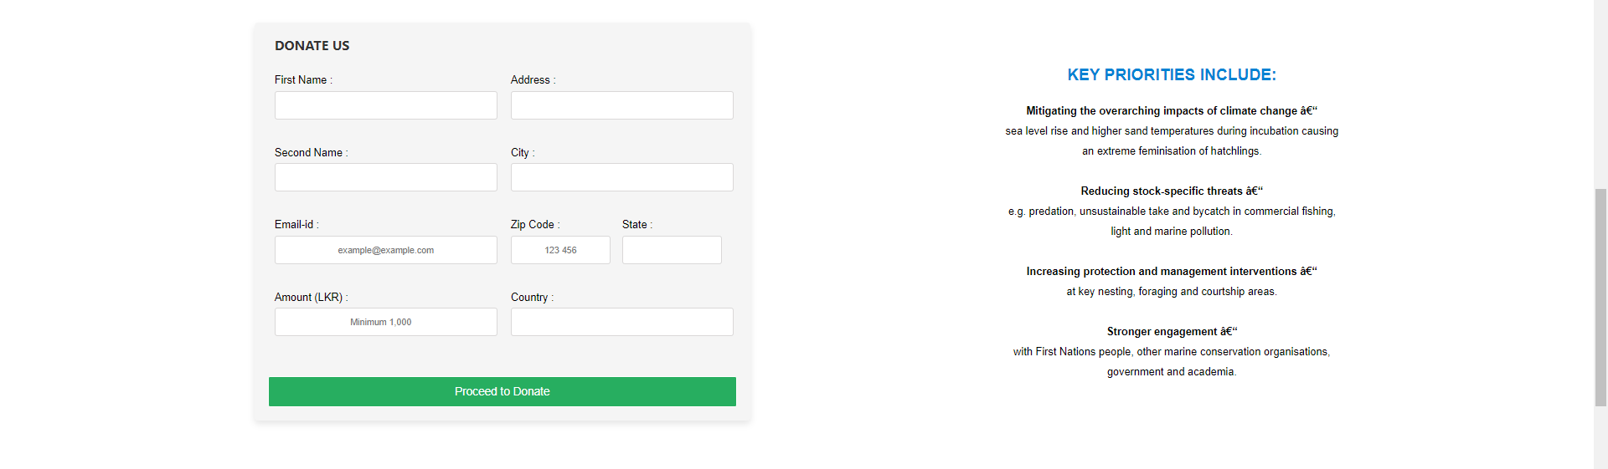

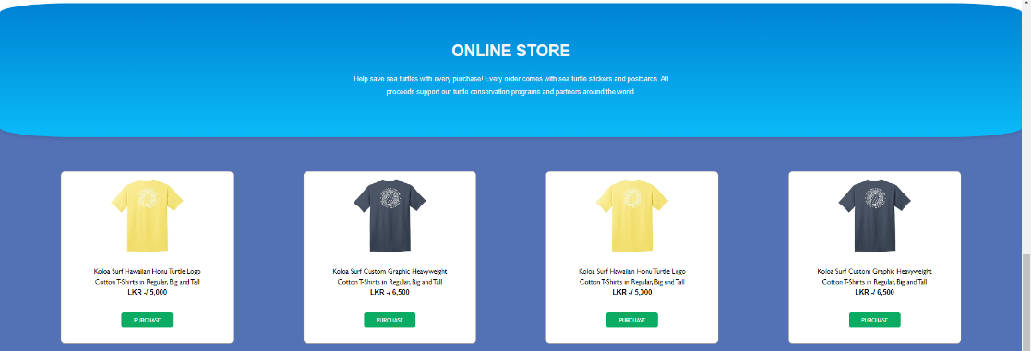

# A screenshot of a computer Description automatically generated with low confidenceConclusion

This assignment has helped me understand the ways to create, design and host websites.

# References (Content on Website)

Daily News. (1998, April 17). *Tripod.com*. Retrieved from The fascinating world of turtles in Sri Lanka: https://hettiarachchi.tripod.com/turtles.html

Love Srilanka. (2022). *Love Srilanka*. Retrieved from Bentota Turtle Hatchery: https://www.lovesrilanka.org/turtle-hatchery/

Sea Turtle Foundation. (2023). *Sea Turtle Foundation*. Retrieved from Donate - Sea Turtle Foundation: https://seaturtlefoundation.org/donate

Selikta. (2013). *Sea Turtle Conservation Project*. Retrieved from Marine Turtles: http://www.sltcp.org/marine-turtles-tcp-sri-lanka/

SWOT. (2018). *SWOT*. Retrieved from Threats to Sea Turles: https://www.seaturtlestatus.org/threats-to-turtles#:~:text=Expert%20members%20of%20the%20IUCN,direct%20take%2C%20and%20climate%20change.

Turtle, M. (2023, February 13). *Time travel Turtle*. Retrieved from Kosgoda Turtle Hatchery: https://www.timetravelturtle.com/kosgoda-turtle-hatchery-sri-lanka/

(Selikta, 2013)

(Daily News, 1998)

(SWOT, 2018)

(Turtle, 2023)

(Love Srilanka, 2022)

(Sea Turtle Foundation, 2023)